*With One Voice* [location]

## With One Voice [location] has been bringing local community members to sing together each week since [year]. Our inclusive choir is made up of people of all ages, faiths, cultures and backgrounds who connect through the power of music.

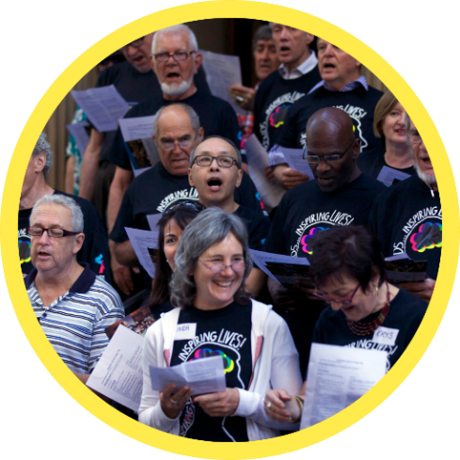We are supported by [insert any funders] and conducted by [conductor name]. We have performed at ____________, and have members from all walks of life across the [location] community.

**About With One Voice programs**  
With One Voice is a national network of community-run choirs that brings together people from all walks of life through the power of music. Our choirs welcome people of all ages, from all faiths, cultures, and backgrounds.

* No auditions
* No singing experience required
* All ages, abilities, faiths, and cultures
* Participation by tax-deductible donation

We operate inclusive choirs, and we are committed to ensuring that price isn’t a barrier to entry for any of our members. This means that a number of our members have their membership subsidised by grants, fundraising, and sponsorship. Your support means that we can continue to deliver community and connection to these members who wouldn’t otherwise be able to participate.

**About Creativity Australia**  
Creativity Australia ([www.creativityaustralia.org.au](http://www.creativityaustralia.org.au/)) is celebrating 15 Years of building a happier, healthier, more inclusive nation through the life-changing With One Voice program. Loneliness, and the depression which accompanies it, is the global epidemic of our era. Statistics show that 2 in 5 people feel socially isolated and unheard. This isolation leads to serious mental and physical health issues and great economic disadvantage. These people risk being left behind.

We bridge the gap between people experiencing disadvantage and those more fortunate through the neuro-scientific benefits of community singing. We build supportive networks that help people connect to brighter futures.

Together, we can change the world… one voice at a time.

**Our social impact goal**Creativity Australia’s social impact goal is to help break down the traditional silos of the social welfare sector, building cohesive communities that include and support one another, rather than relying on ‘top-down’ services. Thus, we mobilise and multiply community change-makers far beyond the capacity of our organisation: diverse people who will pay it forward and help address the deep issues that impact our society.

Our innovative model is ground-breaking in the social innovation/welfare space, as it brings the fortunate and the marginalised together as ONE community to reduce inequality and create a sense of ‘WE’ rather than the current ‘us and them’ environment and gives many people a voice and sense of belonging.

## What could a partnership look like?

Below are some suggestions for what a partnership between our communities could look like – but we’re always happy to discuss and come to an agreement that works well for both of us.

**Sponsor a membership or conductor**  
It costs just $11.50 a week, or $600 a year, to support one *With One Voice* member to participate in our program. For $2,500 a year, you can provide support for the choir to cover to the cost of their rehearsal venue. For $12,000 a year, you can sponsor our experienced professional conductor to provide their services to the choir.

**Book us for a gig**   
For a tax-deductible donation, our choir can come and provide entertainment for an event. Our choir performances are uplifting, joyous affairs where we encourage everyone to experience the joy of singing together.

**Come along to a trial choir session**   
Are you interested in singing yourself? Come along to one of our rehearsals for a free trial! Come along any week you like, there’s no need to book beforehand.

**Spread the word**   
We’re always looking for more members – help us spread the word about our choir by putting up a poster or sharing us on social media!

**Corporate team building**  
Our conductor can come to your workplace or company event and provide a team building singing session. Singing with others has been shown to create a sense of social cohesion and belonging faster than almost any other group activity. This allows your organisation to experience the joy that our members experience every week at rehearsal!

**Provide a venue**   
Our choir rehearses at _____ for a nominal fee. Some of our choirs have local businesses that support us by providing a space to rehearse for free. In return we bring visibility, foot traffic and potential new business to our venues.

**Sponsor your staff**  
As part of a pastoral care or well-being program, your organisation could sponsor a number of staff to participate in our choir.

**What do you get in return for your support?**   
We are very happy to discuss what might be most useful to you! Your company name and logo could be listed on our choir’s webpage, social media, and any printed material. We can also give you a shout-out at our performances and list you as a supporter in our Annual Report. This allows you to promote your services to our community and reinforce your positive public image.

Contact us to find out more about With One Voice [Location]

Name

Email

Phone