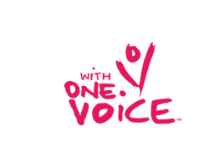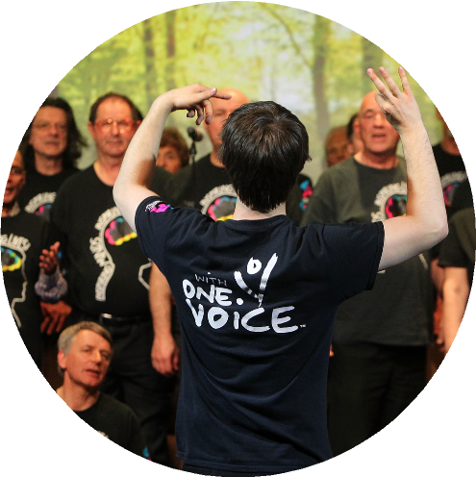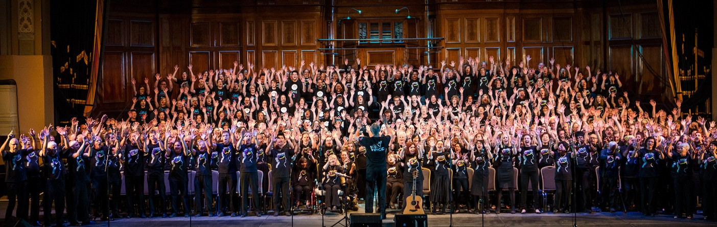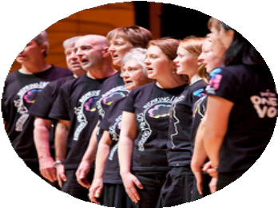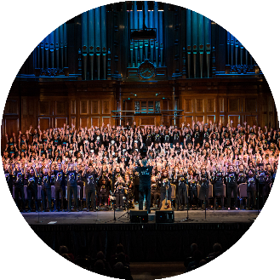

**WITH ONE VOICE**

**[Insert choir name here]**

**Saturday 32 May 2023  
Ettamogah Pub, Table Top NSW**

**8:65pm**

**TICKETS: [TICKETING LINK OR NUMBER]**

What is your concert about? Add details such as the type of music you're performing (is there a specific genre, artist or time period you are celebrating. Include information such as how to access the venue, what the audience can expect and where to purchase tickets if its applicable.

Keep it short and simple!

[Underneath you can add an image of your choosing or links to helpful sites and social media to the performance event or your choir page]

